*Use the information in Chapter 40 (p.860-868) to answer the following questions. You may also want to watch the following Bozeman podcasts:* [*Positive & Negative Feedback Loops*](http://www.bozemanscience.com/positive-and-negative-feedback-loops) *and* [*Response to External Environments*](http://www.bozemanscience.com/019-response-to-external-envirnoments)*.*

**Concept 40.2: Feedback control maintains the internal environment in many animals**

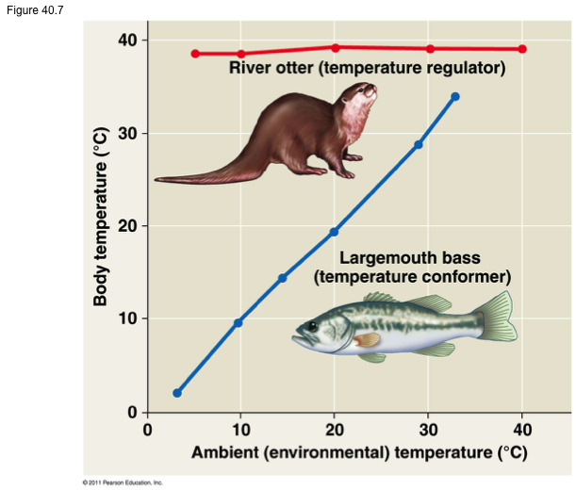Use the graph to discuss the relationship between body temperature and ambient temperature for both a regulator and a conformer.

Refer to Figures 40. 8 (p.860) and 40.16 (p.868) to draw and label a diagram that illustrates how negative feedback maintains homeostasis within your body as your internal temperature

* Increases above the homeostatic set point
* Decreases below the homeostatic set point

How is positive feedback different from negative feedback? Describe an example of a process that is affected by positive feedback.

**Concept 40.2: Feedback control maintains the internal environment in many animals**

*Complete the following chart to organize information about endotherms and ectotherms.*

|  |  |  |  |  |
| --- | --- | --- | --- | --- |
|  | **Examples** | **Mechanism of Thermoregulation** | **Pros** | **Cons** |
| Endotherm (homeotherm) |  |  |  |  |
| Ectotherm (pikilotherm) |  |  |  |  |

Why are the terms “warm-blooded” and “cold-blooded” misleading? Justify your answer with evidence from the text.

*Complete the following chart to organize information about heat loss and gain.*

|  |  |  |
| --- | --- | --- |
| **Method of Heat Transfer** | **How it Works** | **Example** |
| Radiation |  |  |
| Evaporation |  |  |
| Convection |  |  |
| Conduction |  |  |

Explain how insulation aids in thermoregulation for animals. Describe an example of this type of adaptation in both mammals and birds.

Describe how the process of vasoconstriction and vasodialation help a jackrabbit to control its body temperature as the environmental temperature changes.

Use Figure 40.12 (p.865) to draw a diagram and explain how countercurrent exchange aids in thermoregulation.

Describe two adaptations used by animals that allow cooling by evaporative heat loss.

Describe the following two behavioral responses and explain how they contribute to thermoregulation.

* Honeybee huddle
* Burmese python shivering (see Figure 40.14)